
COMSATS University, Islamabad

Experiment # 3
Measurement of Resistivity & Conductivity of Eureka Wire

Author: Muhammad Mujtaba
SP22-BSE-036

Course: Applied Physics for Engineers (PHY-121)

Instructor: Dr. Lubna Tabassum

Date: March 15, 2022

Abstract

In this experiment, we calculated resistivity and conductivity of Eureka wire. We did this by first measuring voltage and corresponding current. We than calculated resistance by formula R = V/I. We also took measurement of length of eureka wire and its diameter. Finally, we calculated resistivity by the formula:
ρ = R x A / L Ohms-cm
After that, we calculated conductivity by taking inverse of resistivity.

Equipment

Power supply with ammeter and voltmeter, eureka wire, copper wire, screw gauge, meter rod, connecting wires.

Procedure

- Construct the circuit as shown in the diagram below.

- Switch on the power supply and give a small current in the wire, record this current and corresponding voltage across the wire from the meters on the power supply.

- Keep on changing current on regular intervals and record the corresponding voltage.

- Find the resistance, and than calculate average resistance.

- Find the diameter and length of eureka wire.

- Calculate area by the given data. Also calculate the resistivity and conductivity.

Diagram
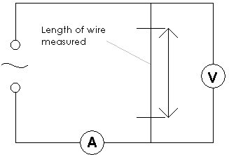
Data & Calculations

Current (A) | Voltage (V) | Resistance R=V/I | Conductance (1/R)
0.6 | 1 | 1.67 | 0.6
1 | 1.8 | 1.8 | 0.556
1.5 | 2.4 | 1.6 | 0.625
1.82 | 3.3 | 1.8 | 0.55
2 | 3.5 | 1.75 | 0.57
2.47 | 4.9 | 1.9 | 0.50
3 | 5.5 | 1.8 | 0.54
4.13 | 8 | 1.9 | 0.51
5.37 | 9.4 | 1.75 | 0.57

Calculations
We have,
length of wire L = 5 cm
diameter of wire D = 0.029 cm
radius of wire r = D/2 = 0.014 cm
cross-section area of wire A = πr² = 0.0006 cm⁻²

average resistance = R = 1.79 ohm
average conductance = 1/R = 0.56 ohm⁻¹

resistivity of wire = ρ = R x A / L = 1.79 ohm x 0.0006 cm⁻² / 5 cm = 0.0002148 Ohms-cm
conductivity of wire = σ = 1/ρ = 4655.5 Ohms⁻¹-cm⁻¹

Graph
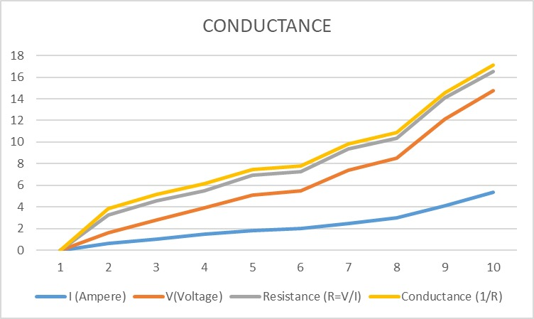
Result
We successfully calculated the resistivity and conductivity of eureka wire:

- resistivity of wire = ρ = R x A / L = 1.79 ohm x 0.0006 cm⁻² / 5 cm = 0.0002148 Ohms-cm
- conductivity of wire = σ = 1/ρ = 4655.5 Ohms⁻¹-cm⁻¹

Precautions

- Provide small current to wire for short interval to avoid heating.

- At least 12 readings are recommended.

- To reduce error, take many readings of diameter, and than take average.

